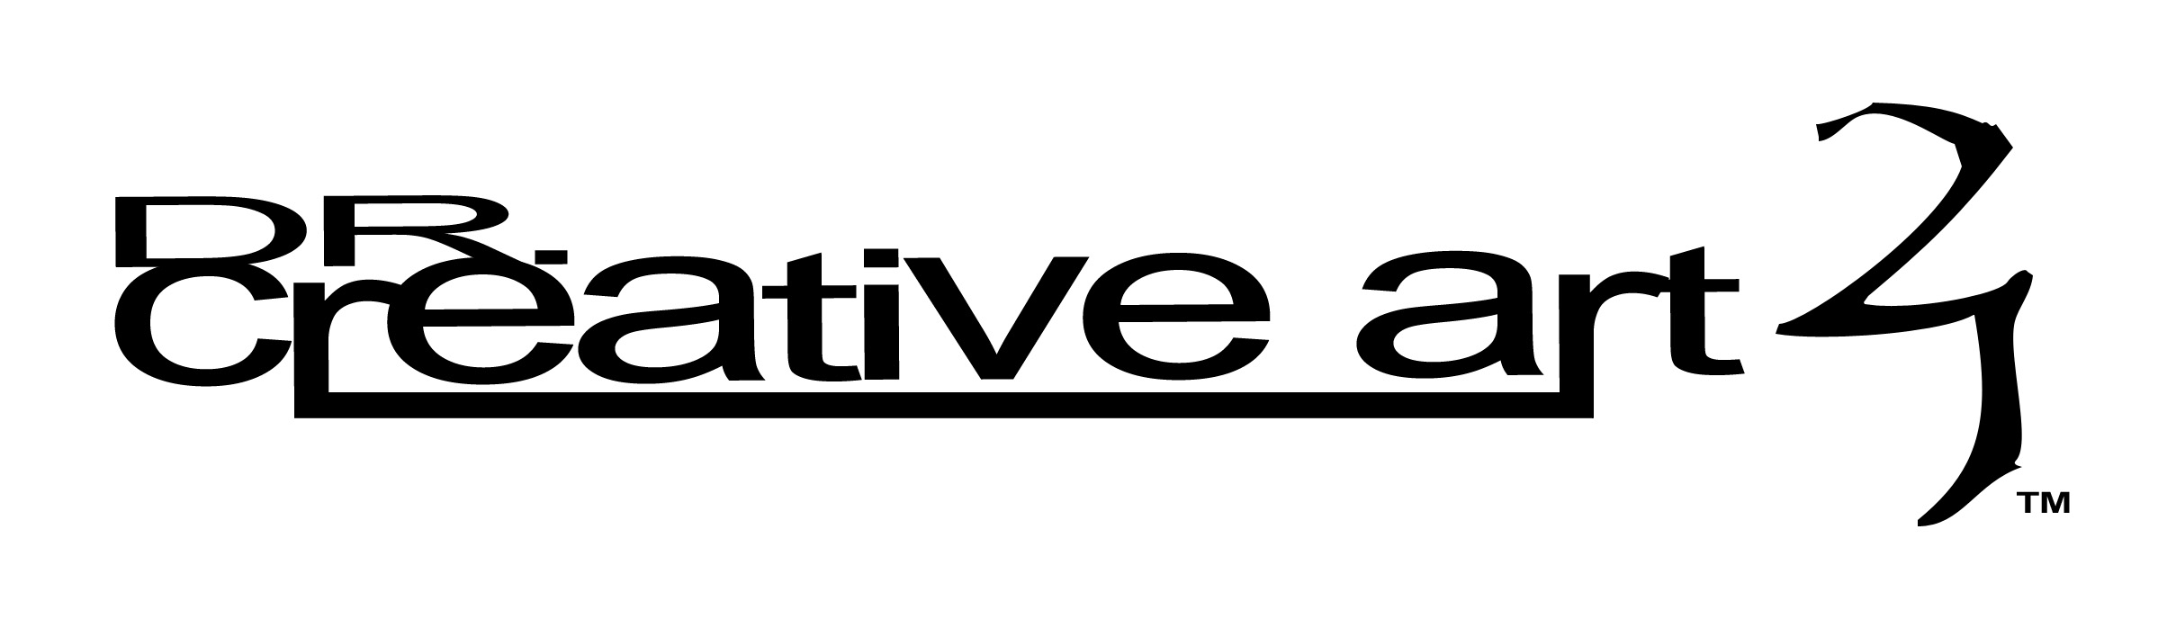
Website Creation Assistant

Much time can be spent designing and redesigning a website. The best defense against wasted time is to know as many details as possible before beginning.

Respond to the following questions/statements with as much detail as possible.

Development
Is the website name available?
Have I purchased or reserved the site name?
State the site’s purpose in 1-2 sentences.
Who is the target audience for this site?
What is the feeling I want people to have when they visit the site?
What kind of tone do I want (technical language, slang, standard English, etc.)?

Design
What type of website do I need to fulfill my purpose (informational, animated, ecommerce, social, etc.)?
What features do I need on my site for my site viewers’ convenience (shopping cart, payment
Have I seen a site that I would like to pattern my site after?
Do I want this site to work well on people’s mobile phones or just their computers?
What pages do I need to have for my site visitors (home/main page, contact page, history page, supporter page, photos, etc.)?
Do I want/need to leave space in the site design for future, 3rd party advertisements?
Do I have a digital/graphic business logo ready to use on the site?
Do I have pictures or images collected that I want to be used to design the site?
What colors or color-themes do I want the site to have?

Execution
Do I want to maintain the website myself or have someone else update information?
How often will information on my site be updated?

Additional Notes

